DEFECT REPORT

DEFECT ID: DT001

SUMMARY: MAP LOCATOR REMAINS PINNED TO THE PREVIOUSLY SELECTED STATE AFTER RESETTING THE DROPDOWN TO “SELECT A STATE”

MODULES: COVID TRACKER – STATE DROPDOWN / MAP

LABELS: NEGATIVE TESTING

STEPS TO REPRODUCE:
- navigate to url
- click on drop down menu
- select a state ‘Goa’
- scroll to map section
- observe the location pin
- scroll up and click the drop down
- select default option ‘Select a State’
- observe the location pin

EXPECTED RESULTS:
Location pin should disappear and should not point to any state
ACTUAL RESULT:
Previous selection information is retained location pin visible in previously selected state ‘Goa’
SEVERITY: Major
PRIORITY: High
STATUS: New/Open
COMMENTS: Map is retaining the previous selected state behaviour after resetting to default.
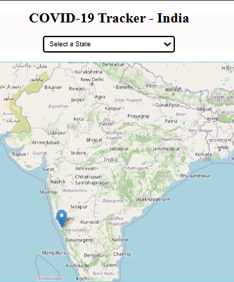

DEFECT REPORT

DEFECT ID: DT002

SUMMARY: TOTAL CASES SHOWN IN THE SUMMARY CARDS DOESN’T ACCURATELY MATCH WITH SUM OF ALL CASES
MODULES: COVID TRACKER – SUMMARY CARD
LABELS: NEGATIVE TESTING

STEPS TO REPRODUCE:
- navigate to url
- click on drop down menu
- select a state ‘Assam’.
- observe the summary cards , calculate the total of all cases and compare it with the total case displayed
- select a state ‘Bihar’
- observe the summary cards , calculate the total of all cases and compare it with the total case displayed
- select a state ‘Karnataka’
- observe the summary cards , calculate the total of all cases and compare it with the total case displayed

EXPECTED RESULT:
Total case value should exactly match with sum of all cases.
SEVERITY: Major
PRIORITY: High
STATUS: New/Open
COMMENTS: mismatch in data is leading to data inconsistency.
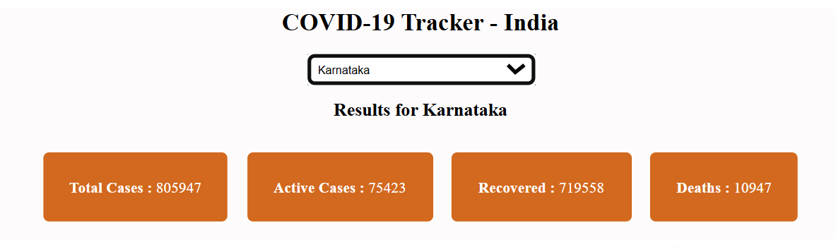
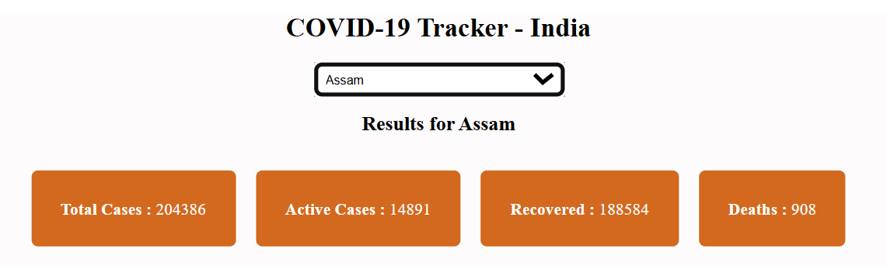

DEFECT REPORT

DEFECT ID: DT003
SUMMARY: PIE CHART INCORRECTLY DISPLAYS “TOTAL CASES” AS A SEPARATE SLICE

MODULES: COVID TRACKER – PIE CHART

LABELS: UI TESTING

STEPS TO REPRODUCE:
- navigate to url
- select a state from drop down ‘Kerala’
- observe the pie chart

EXPECTED RESULTS:
Pie chart should only display Active,Recovered and Deaths as slices in pie chart.

ACTUAL RESULT:
Total Cases are shown as a slice

SEVERITY: Major
PRIORITY: High
STATUS: New/Open

COMMENTS: The pie chart incorrectly represents “Total Cases” as a separate slice, which can mislead users. Total is already a aggregated value showing it can mislead.

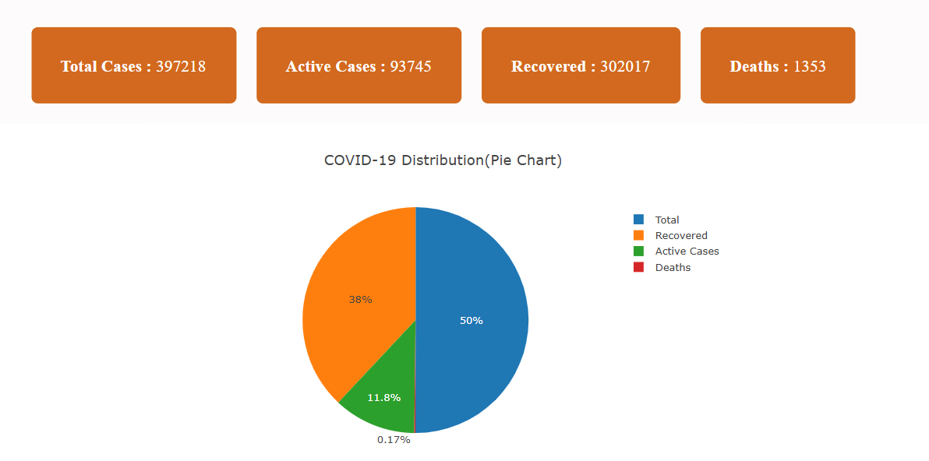

DEFECT REPORT

DEFECT ID: DT004

SUMMARY: VISIBILITY OF SLICES WITH SMALLER VALUES ARE LOW

MODULES: COVID TRACKER – PIE CHART

LABELS: UI TESTING

STEPS TO REPRODUCE:
- navigate to url
- select a state from drop down ‘Kerala’
- observe the pie chart

EXPECTED RESULT:
All slices should have clear visibility irrespective of the value

ACTUAL RESULT:
Slices with smaller values have very low visibility.

SEVERITY: Minor

PRIORITY: Medium

STATUS: New/Open

COMMENTS: low visibility of slices with lower value makes interpretation difficult.
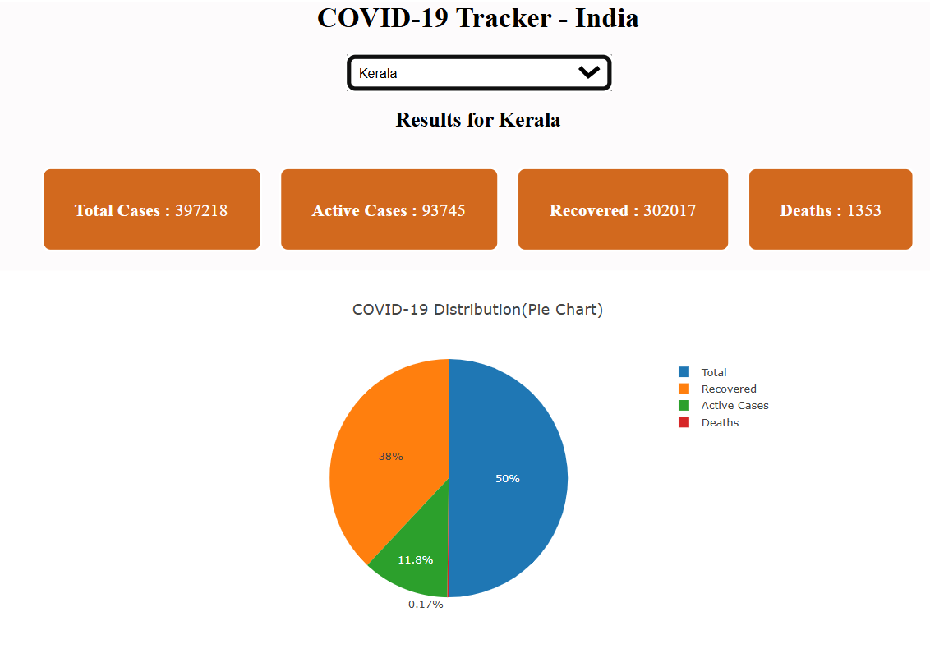

DEFECT REPORT

DEFECT ID: DT005

SUMMARY: Y- AXIS IS NOT CLEARLY VISIBLE IN THE LINE CHART

MODULES: COVID TRACKER – LINE CHART

LABELS: UI TESTING

STEPS TO REPRODUCE:
navigate to url
select a state from drop down ‘Kerala’
observe the line chart

EXPECTED RESULT:
X/Y axis should be clearly visible
ACTUAL RESULT:
Y axis is not visible

SEVERITY: Major

PRIORITY: High

STATUS: New/Open

COMMENTS: low visibility of Y axis can lead to misinterpretations
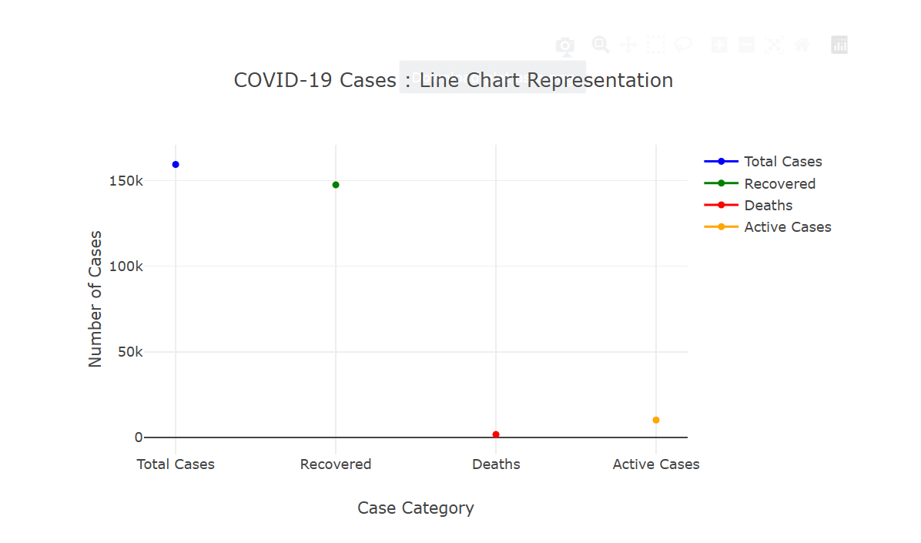

DEFECT REPORT

DEFECT ID: DT006

SUMMARY: CATEGORY NAMES AND AXIS NAME IS OVERLAPPING IN LINE CHART

MODULES: COVID TRACKER – LINE CHART

LABELS: UI TESTING

STEPS TO REPRODUCE:
navigate to url
select a state from drop down ‘Kerala’
observe the line chart

EXPECTED RESULT:
Category name and axis name should not overlap
ACTUAL RESULT:
Category name and x axis name are overlapping
SEVERITY: Major

PRIORITY: Medium

STATUS: New/Open

COMMENTS: overlapping can affect the readability

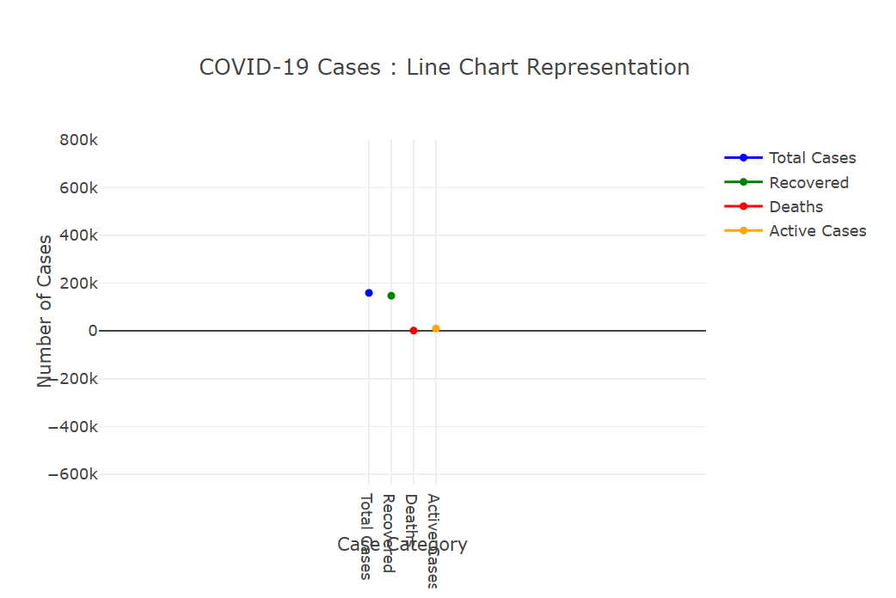

DEFECT REPORT

DEFECT ID: DT007

SUMMARY:INCORRECT SPELLING OF STATE
MODULES: COVID TRACKER – DROP DOWN

LABELS: UI TESTING

STEPS TO REPRODUCE:
- navigate to url
- select a state from drop down ‘Kerala’
- observe the line chart

EXPECTED RESULT:
State name should be ‘Keralam’
ACTUAL RESULT:
State name shown is ‘Kerala’
SEVERITY: Minor

PRIORITY: Medium

STATUS: New/Open

COMMENTS: spelling error in the state ‘kerala’

